# CU Robosub team

# 8/29/2018

# Kill Switch/ESC Board

# 

# 

**Abstract** **3**

**Design Requirements** **3**

**Design Overview** **3**

Previous designs 3

**System descriptions** **3**

Recom and Kill Switch 4

**System status** **4**

**Known Issues** **5**

**Appendix** **5**

# 

# Abstract

The kill switch board controls all power to the ESC modules and therefore the motors. This board can cut the power to the motors based off the kill switch’s state, allowing voltage to pass through the onboard mosfets to ground or holding the voltage high so the motors have nothing to work off of.

# Design Requirements

The kill switch board must:

* Receive input power and ground connections from the backplane.
* Route proper connections for power and ground to every ESC module.
* Use the kill switch’s state to properly turn off the motors.
* Not overheat from the amount of current passing through it.

# Design Overview

All of the ESC modules are controlled by N-channel mosfets that had their gate connected to a 5V line which could be broken by the kill switch. The mosfet’s controlled the motor’s connection to ground, so if the kill switch was active, then the motors would float at 14.8V with no way to draw current and turn. When the kill switch was disabled, the 5V line would activate the mosfets which allowed the motors to create a complete circuit and rotate as desired by the Pololu controller.

## Previous designs

Previously, this board was combined with the merge board due to the power requirements of the motors and the sub. The previous design was functional, but there was too much power on that pcb, without proper thermal considerations, so it started melting off soldered components. The mosfets also were not reliable and several broke from various incidents of polarity and misuse.

# System descriptions

Shown below is the completed kill switch board design. Red represents top layer traces while blue represents bottom level traces. This board ended up being a four layer PCB in order to route power and ground planes more efficiently and to potentially improve thermals with extra copper pours.

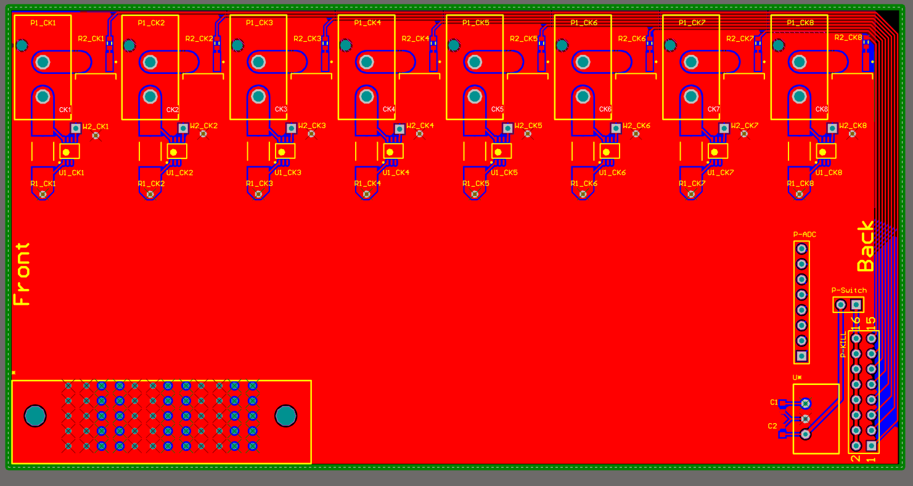

The top two layers of this board were reserved for the ground plane so that the mosfets could easily connect to the plane and pass as much current to it as needed. These planes were connected through a lattice of vias, not shown in the picture, to assure proper connections and thermal availability. The bottom two layers were set as the power plane that connected to the through-hole molex connectors. These connectors were for the ESC’s to connect to in a polarized way that couldn’t reverse polarity on accident like the previous bullet connectors. These bottom two planes were connected by more latticed vias to assure proper power distribution throughout the board. AD8217s were used as current monitors for the ESC inputs.

## Recom and Kill Switch

In the bottom right corner of this board a recom 5V converter was provided to create a gate signal for all of the mosfets. This voltage line immediately connected to the kill switch so that we could control the gate signals. The kill switch was soldered between the two horizontal vias labeled as p-switch. From the other end of the killswitch we created a row of jumper headers to connect all of the gates to the signal in an easy way. Due to the Recom’s max current specs and good electrical practices, we also implemented 1KOhm resistors in series in front of the gates to not kill the mosfets if any power spikes did occur for any reason.

# System status

This system was completed and ran successfully on the 2018 sub Leviathan. No major issues were experienced after soldering.

# Known Issues

* This board is potentially not needed. Due to the Pololu Motor Controller’s reset pin, we can cut all motors without this board. Resetting the Pololu will remove all data inputs for the ESC’s and they will stop providing power to the motors.
* Wrong mosfet connections. Flip source and drain routing for proper function
* Schematics only show boxes for the mosfets instead of their internal design. (This created the wrong mosfet orientation problem)
* Forgotten pulldown resistor from mosfet gates to GND
* Kill Switch soldering vias were easily stripped/deplated. Switch to Molex connectors

# Appendix

N-Channel Mosfets: <https://www.digikey.com/product-detail/en/infineon-technologies/IRLR6225TRPBF/IRLR6225TRPBFCT-ND/2538170>

5V converter: <https://www.digikey.com/product-detail/en/recom-power/R-78E5.0-0.5/945-1648-5-ND/2834904>

ESC Connectors:

<https://www.molex.com/molex/products/datasheet.jsp?part=active/0768290102_PCB_HEADERS.xml>